Robert Weischedel

CS 5780

2/28/17

Lab 4 Post Lab

Logic Analyzer Images for two different images. The first image is where I transmitted the letter c in the while loop infinitely. The second image is where I send the CMD? Message when I first start the transaction, for the post lab portion of the assignment.

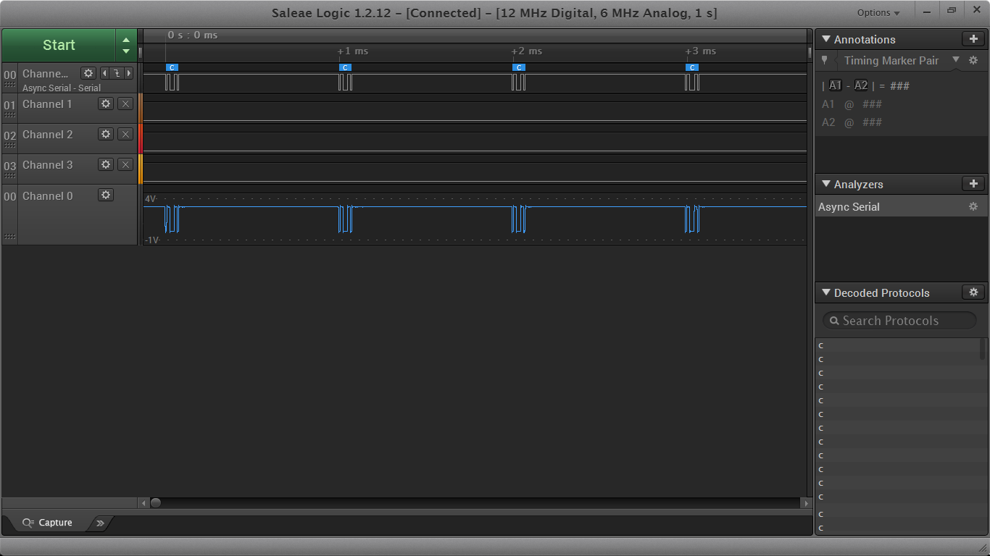

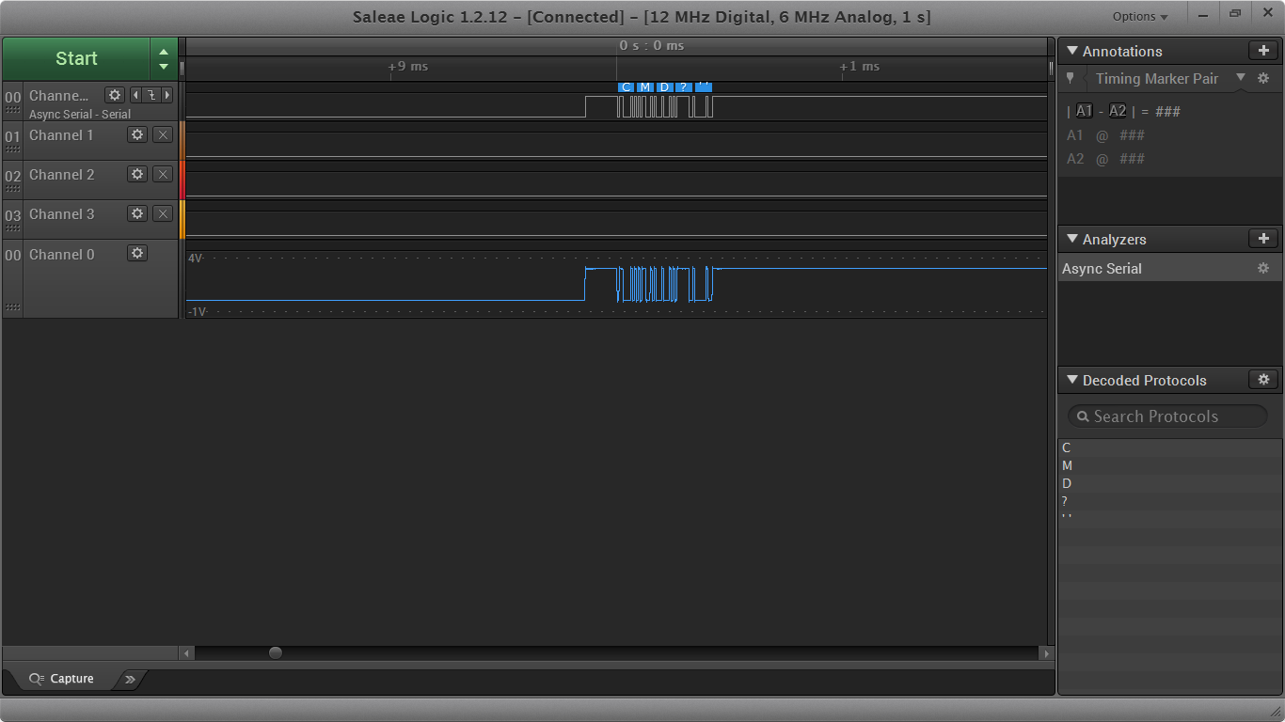

Summary of My Code

For my post lab code, I simply placed all the needed methods and code within the main.c file. I first set up the correct NVIC interrupt controller and method USART3_4_IRQHandler. Within the handler I call my get_char method. This method receives the char from the Serial Port, and then places that value in the buffer. If the char value entered is the entered is the carriage return from the enter button the values in the buffer then processed by the process_input method. This process_input method handles all parsing and checking of the input from the serial port, it first determines what color the user has entered and then sets a flag to know that the next set of input will be the action to be performed. Such as, on, off, and toggle. And then after the action is validated the correct method, on_led, off_led, or toggle_led is called. Then the flag is set back to accept a newly inputed color command, and we return back to get_char. In get_char we then print out a new line and the CMD? String using the send_char and send_cmd methods. The send_char method sends the desired char out to the user using the serial port. There are a few other methods as well that I created such as send_error that sends an error message when incorrect input is given. Another method called clear_buffer empties the buffer after a command is processed. It should be noted that the input is a bit picky on what it accepts, it only accepts all lowercase values and if you misspell the word and regardless of whether you correct it or not it will not be accepted and give you an error.